LINUX BASIC COMMANDS

**SSH --🡪Secure Shell or Secure Socket Shell**

/----->root

/home--->home directory

pwd--->present working directory

mkdir--->make a directory

ls--->long list

ls -l--->will give you all the details like permission time,date of the creation of file

vi filename.text--->create a file and write the content inside the file

press i after that write the content

press esc :wq---where w stands for write/save q---quit and press enter you will be directed out of the file

cat filename .text--->will display the content present in the file

esc :q!--->quit without saving

touch filename.txt--->create a file but will not enter inside the file

whoami--->will display the username

ping--->will display the connectivity

df -h---->free disk space

ls -al--->all the hidden and regular files

clear---->is used to clear the screen

cd command---->change the directory

cd ..--->come out of present working directory

mv--->command to move the filename

mv filename.text (to where u want to move)/

rm --->remove filename

rmdir--->is used to remove the directory inorder to remove the directory the

directory must be empty

to empty the directory we should get inside the directory and remove the file by giving the command rm filename

then come out of the pwd directory and remove the empty directory

chmod---->command is used to change the permission of the file

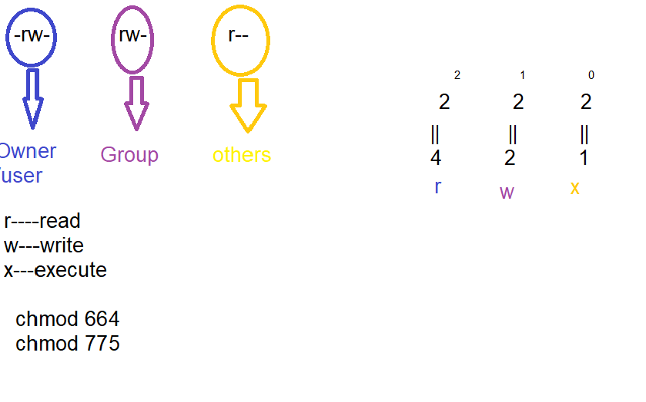

grep---->is used to match the pattern

grep -i---->grep -i "Good" filename.text it will display the matching content

grep -n---> will display the line number grep -n "Good" filename.text

grep -c--->will display the number of times the content is displayed. grep -c "Good" filename.text

copy file from 1 file to another

cp filename.text (file name where u want to copy the previous file)

netstat command not found

yum -y install net-tools

netstat--->will show how many services are running along with port number.

netstat | tail -n4---last 4 lines of netstat

netstat |head -n4---first 4 lines of netstat

sudo su---super user mode

ps -al--->process id will be displayed

ps -ef---->all hidden and running process id will be displayed

kill--->is a command to kill a process(but in built process cannot be killed)

kill command can be used only gto kill the user created process.

How to print or display something in the console?

echo "this is my first linux program"

/usr----->all the external executables files will be stored in usr

/home---->user related information will be available in home

/boot--->all unix related boot files like restart, shutdown all these information will be stored in boot

cat /etc/redhat-release -🡪check linux/red hat version

What is SSH and why it is used?

SSH or Secure Shell is **a network communication protocol that enables two computers to communicate** (http or hypertext transfer protocol, which is the protocol used to transfer hypertext such as web pages) and share data.

JDK INSTALLATION

Sudo yum install java-1.8.0-🡪java installation

wget---to install the jdk

java -version----->version of java that is installed

to set environment variable===export JAVA_HOME=/usr/java/jdk1.8.0

to check the path---> echo $JAVA_HOME

